More Regular Expressions: Using Lookarounds to Parse Data SOP

Sample.txt file content

Removing extra spaces

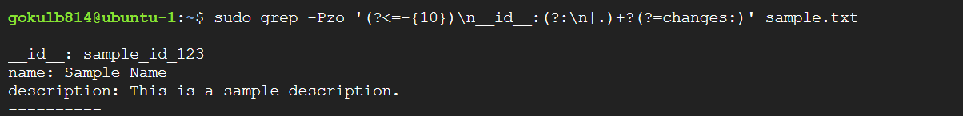

Text between **“----------” and “changes:”**